Working Note
Monday 29 August, 2022
COVID-19 Transport Survey, Perth
Sampling frame

Dr James Reynolds

Introduction

PTRG is preparing for a survey of COVID-19-related transport impacts in the Great Perth region. Part of this involves understanding the sampling frame necessary to obtain a representative survey of the Perth population. This working note outlines details of the relevant 2016 Census data, and the calculation of population thresholds for age and income by Local Government Area (LGA). A map of the Perth area, LGA boundaries and railway lines is also included.

Population thresholds by age (18+: low, mid, high) and income (nil, low, mid, high)
The 2016 Census data for Greater Perth reports a median age of 36, with 19.1% of the population being less than 15 and 13.8% being 65 or older. Figure 1 shows age profile of Greater Perth’s population as well as cumulative population values for both the entire and the 18+ population.

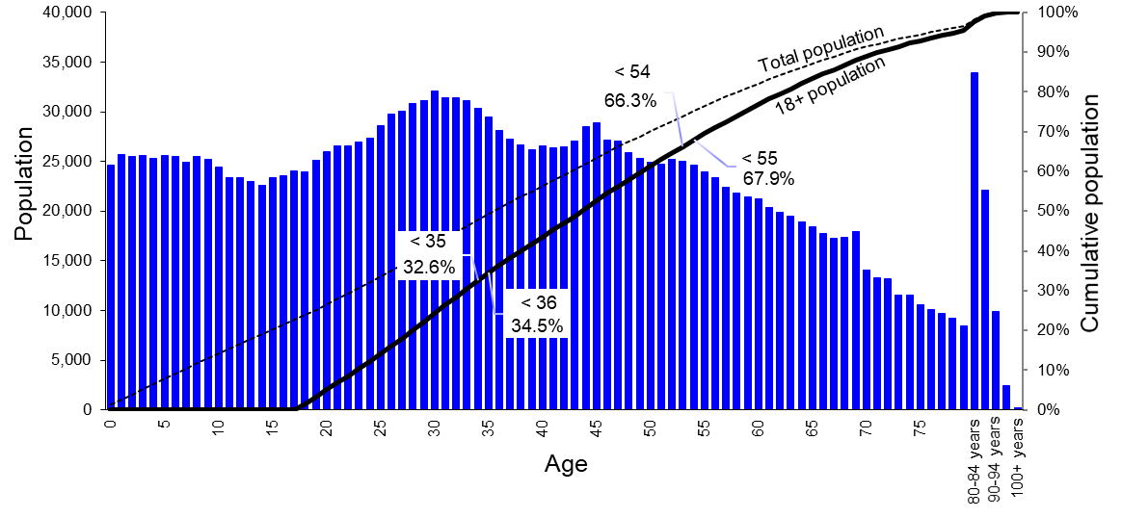
Figure 1 2016 Greater Perth population by age, and cumulative population for all and for 18+. Source: Table G04, Australian Bureau of Statistics [1].

Figure 1 shows that 32.6% of the 18 and over population were 34 or younger, 33.7% were 35 to 54 years old, and the remaining 33.7% were 55 or older.

Figure 2 and Figure 3 show the Greater Perth population by weekly income for those aged 15 and over, and for those aged 20 and over.
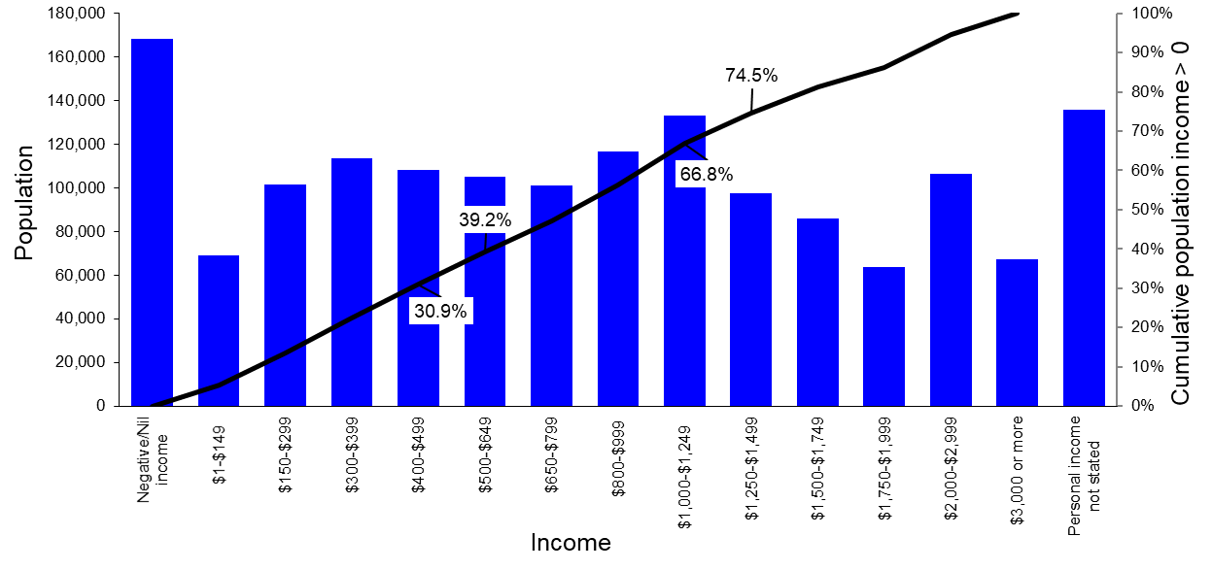
Figure 2 2016 Greater Perth 15+ population by weekly income, and cumulative population for those earning > 0. Source: Table G17, Australian Bureau of Statistics [1]

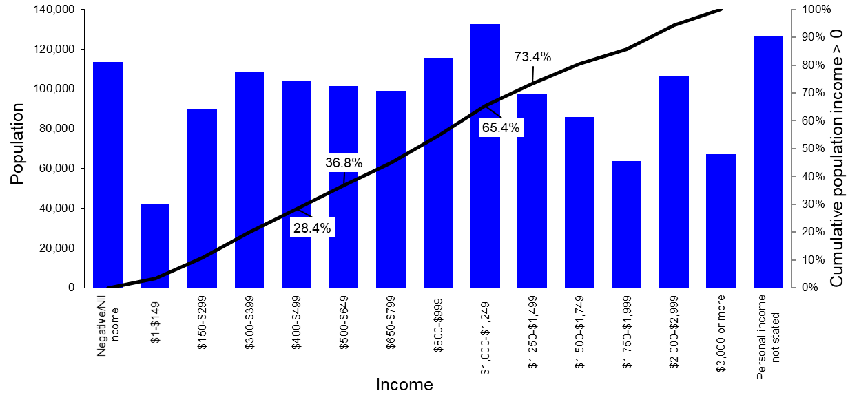
Figure 3 2016 Greater Perth 20+ population by weekly income, and cumulative population for those earning > 0. Source: Table G17, Australian Bureau of Statistics [1]

Figure 2 and Figure 3 show how the ABS reported census data only shows personal income in $150 to $1,000 wide bins. Hence, it is not possible to obtain an exactly even split of income into three groups. However, Table 1 shows a grouping to obtain as close to a 33% even split as is feasible.

Table 1 2016 Greater Perth population by weekly income (not stated, nil or negative, low, mid, high). Source: calculated from Table G17, Australian Bureau of Statistics [1]
Age | Income
Age | Not stated | Nil or negative | $1 to $649 | $650 to $1,249 | $1,250+ | Total
15+ | 135,758 (8.6%) | 1,437,778 |  |  |  | 1,573,546
15+ |  | 168,449 (11.8%) | 1,269,329 |  |  | 1,437,778
15+ |  |  | 497,845 (39.2%) | 350,626 (27.6%) | 420,868 (33.2%) | 1,269,339
20+ | 126,376 (8.7%) | 1,327,031 |  |  |  | 1,453,417
20+ |  | 113,429 (8.5%) | 1,213,602 |  |  | 1,327,031
20+ |  |  | 446,068 (36.8%) | 347,042 (28.6%) | 420,502 (34.6%) | 1,213,602
As shown in Table 1, almost 9% of the 15+ and 20+ population did not provide a response to the personal income question. Amongst those who did, 11.8% and 8.5% of the 15+ and 20+ population respectively stated they had a negative or no income. Amongst those who did have an income, roughly one-third had a weekly income $649 or less, one-third had an income of $650 to $1,249, and the remaining third earned $1,250 or more. Adjusting these values according to the inflation calculator provided by the Reserve Bank of Australia [2] shows that in 2021 dollars these ranges would be $1 to $711, $712 to $1368, and $1,369 and above.

LGAs, Greater Capital City Statistical Areas (GCCSAs) and other boundaries
Figure 4 shows the Greater Perth GCCSA, together with Statistical Arear Level 4 (SA4) boundaries. Figure 5 shows LGA boundaries and railways within the GCCSA.
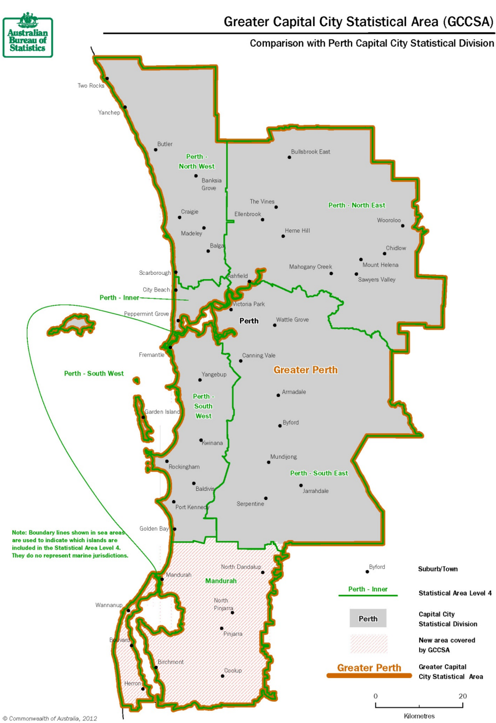
Figure 4 Greater Perth GCCSA and SA4 boundaries. Source: Australian Bureau of Statistics [3].

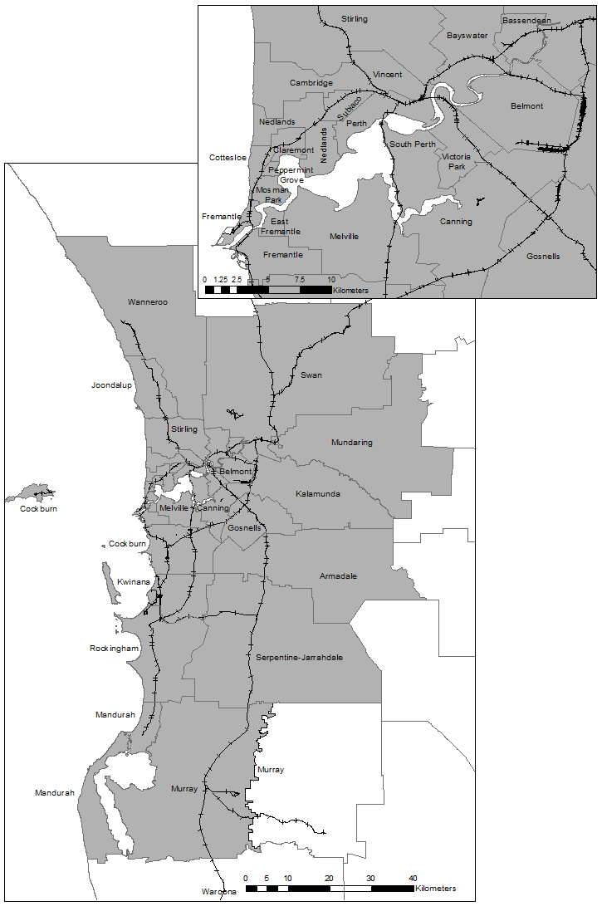
Figure 5 Greater Perth GCCSA and LGA boundaries, and railway network. Source: Australian Bureau of Statistics [4] and [5]
As shown in Figure 5 the Greater Perth GCCSA includes the following LGAs: Armadale, Bassendean, Bayswater, Cambridge, Canning, Claremont, Cockburn, Cottesloe, East Fremantle, Fremantle, Gosnells, Joondalup, Kalamunda, Kwinana, Mandurah, Melville, Mosman Park, Mundaring, (roughly half of) Murray, Nedlands, Peppermint Grove, Perth, Rockingham, Serpentine-Jarrahdale, South Perth, Stirling, Subiaco, Swan, Victoria Park, Vincent and Wanneroo.

Age/income profiles, journey to work mode split, and WFH
Population by age and income groups (15-34, 20-34, 35-54, 55+; and Nil, $1 to $649, $650 to $1,249 and $1,250), WFH percentage, and journey to work train and bus mode split are shown for each LGA in the attached excel spreadsheet (Greater Perth sampling frame analysis 220828.xls). The values for the entire Perth GCCSA are shown in Table 2

Table 2 Perth GCCSA age and income profile, total population, journey to work mode split and WFH. Source: Australian Bureau of Statistics [6]
 | Income
Age | Not stated | Nil or negative | $1 to $649 | $650 to $1,249 | $1,250+ | Total | Total (stated)
15-34 | 47,037 | 97,060 | 174,628 | 129,586 | 111,921 | 560,232 | 513,195
20-34 | 37,655 | 42,040 | 122,851 | 126,002 | 111,555 | 440,103 | 402,448
35-54 | 39,704 | 38,928 | 106,756 | 128,063 | 217,853 | 531,304 | 491,600
55+ | 49,014 | 32,453 | 216,445 | 92,977 | 91,090 | 481,979 | 432,965
Total 15+ | 135,755 | 168,441 | 497,829 | 350,626 | 420,864 | 1,573,515 | 1,437,760
Total population
0+ | 1,943,868
15+ | 1,573,538
20+ | 1,453,409
Journey to work mode split
Train | 7.2% | Bus + Train included in both |  | Bus + Train is: | 1.8%
Bus | 6.6%
Work from home
Share of workers |  | 3.9%
Share of 15+ |  | 2.3%
Share of 20+ |  | 2.4%
Share of total |  | 1.8%

There were 1.94 million people living in the Perth GCCSA at the time of the 2016 census. 1.44 million people who were 15 years or older stated their weekly income. The ABS statistics show incomes by age range, with the two lowest groups being 15-19 and 20-24. Almost 170,000 (12%) had no or a negative income, being made up of:
- A little over 97,000 (7% of 15+ population) being 15-34;
- Almost 39,000 (3%) being 35-54; and
- Almost 32,500 (2%) being 55 or over.
Almost 500,000 (35%) had $1 to $649 in weekly income, made up of:
- Almost 175,000 (12% of 15+ population) being 15-34;
- Almost 107,000 (7%) being 35-54; and
- Almost 216,500 (15%) being 55 or over.
Almost 351,000 (24%) had $650 to $1,249 in weekly income, made up of
- A little over 129,500 (9% of 15+ population) being 15-34;
- A little over 128,000 (9%) being 35-54; and
- Almost 93,000 (6%) being 55 or over.
Almost 421,000 (29%) had $1,250+ in weekly income, made up of:
- Almost 120,000 (8% of 15+ population) being 15-34;
- Almost 218,000 (15%) being 35-54; and
- Almost 91,000 (6%) being 55 or over.

Table 2 also shows that the journey to work mode split is 7.2% and 6.6% for train and bus, respectively, including (double counting) those using both train and bus. Counting separately, the mode split is 5.4% train, 4.8% bus and 1.8% train and bus. 3.9% of workers did WFH on the day of the census.

References

